General Plan 2026 Locations  If you would like to view the City of Safford General Plan 2026, paper copies of the Plan are available at the following locations:  Safford City-Graham County Public Library, 808 S 7th Avenue, Safford, Arizona  City of Safford Annex, 808 S 8th Avenue, Safford, Arizona  City of Safford – City Hall, 717 W Main Street, Safford, Arizona  Online at, https://www.cityofsafford.us/922/Safford-General-Plan-Update-2026 |  | City of Safford General Plan 2026  To Read the City of Safford General Plan 2026, Use the Following QR Code:    For More Information, Contact:  Jaime L. Embick, Planning and Community Development Director, City of Safford, Arizona  Email: jembick@saffordaz.gov  Phone: 928-432-4299   |  | City of Safford General Plan 2026  Proposition 405  Frequently Asked Questions    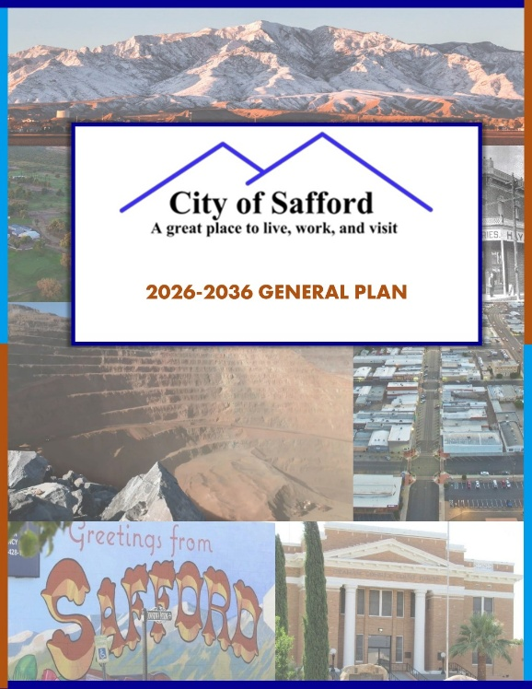

Frequently Asked Questions  What is a General Plan?  General Plans provide a long-range roadmap to guide community development. They define a community’s vision, analyze its challenges and opportunities, and establish goals, policies, and actions to make that vision a reality.  Why does the City of Safford have a General Plan?  State law mandates that the City adopt a General Plan every 10 years. The General Plan guides staff and policymakers on key areas, including growth and land use, housing, transportation, recreation, historic preservation, environmental conservation, and economic development.  How is the General Plan used?  The General Plan serves as a guide for City staff and appointed/elected officials in evaluating development and redevelopment proposals, identifying capital improvement projects, and developing more specific studies to achieve the goals set forth in the Plan. It includes background data and current conditions and provides a policy framework for refining existing implementation tools, such as the zoning ordinance and subdivision regulations, or creating new ones. It also outlines the administrative and monitoring mechanisms needed to manage the General Plan, as well as the strategies for its implementation.  What a General Plan does NOT do:  The General Plan does not change zoning or development regulations, nor does it commit funding. |  | Frequently Asked Questions  What’s changed since the 2016 General Plan?  The City of Safford General Plan 2026 is an update of the 2016 General Plan, which included an extensive public engagement process and was adopted by the City of Safford Mayor and Council. The City of Safford General Plan 2026 maintains many of the goals and policies of the 2016 General Plan, while updating existing conditions and revising for conciseness and user-friendliness. Major themes of the 2016 General Plan have been carried forward.  What is the Vision for the 2026 General Plan?  “The City of Safford is a welcoming, attractive community that blends small-town charm with broad economic opportunity. Safford stands as a destination in the Gila Valley, with a thriving downtown, excellent municipal services, and abundant recreation and sports amenities. Building on its mining and agribusiness legacy, Safford is expanding employment, retail, and service offerings, all supported by safe, livable neighborhoods and attainable housing that guide responsible growth.”  What’s in the 2026 General Plan?  The updated General Plan is divided into 9 chapters, including: 1) Land Use, 2) Transportation and Circulation, 3) Parks, Recreation, Trails, and Open Space, 4) Economic Development, 5) Environmental Planning and Water Resources, 6) Housing, 7) Preservation, Revitalization, and Redevelopment, 8) Public Buildings, Services, and Infrastructure Safety, and 9) Cost of Development. |  | Frequently Asked Questions  Will implementing the Plan result in additional costs for taxpayers? Will the General Plan affect taxes?  No. The adoption of the Plan will not directly impact taxes.  Why is the General Plan being brought before the voters?  Arizona state law requires the City of Safford to submit the General Plan to voters for ratification because Safford’s population now exceeds 10,000. This is the first time the General Plan has appeared on the ballot.  What happens if the City of Safford General Plan 2026 is not approved in this election?  Should the voters not approve the proposed General Plan, the previous General Plan will remain in effect, and the City will need to revise it or develop a new Plan.  If approved, when would the Plan take effect?  If approved by the voters, the Plan would be effective upon adoption of the official canvass of the election. This occurs not more than twenty (20) days after the election.  Where can I get additional information about the proposed General Plan?  Contact the Planning & Community Development Director, Jaime Embick, at jembick@saffordaz.gov or (928) 432-4140.

